XAMPP

🌟 Definition
# Source: AI Source: Provided by: [Data Path: Persons Table -> ID Column: 1, Name_En Column: Motasem Essam] -> From: [ChatGPT] on [6/1/2026]
XAMPP is a free, open-source local server environment that allows developers to run web applications on their own computer without needing an online server.
It bundles several web development components into one package.
Official website:
XAMPP

🧩 What does XAMPP mean?
# Source: AI Source: Provided by: [Data Path: Persons Table -> ID Column: 1, Name_En Column: Motasem Essam] -> From: [ChatGPT] on [6/1/2026]
XAMPP =
- X → Cross-Platform (Windows, Linux, macOS)
- A → Apache (Web Server)
- M → MariaDB (Database System; formerly MySQL)
- P → PHP
- P → Perl

🎯 Purpose
# Source: AI Source: Provided by: [Data Path: Persons Table -> ID Column: 1, Name_En Column: Motasem Essam] -> From: [ChatGPT] on [6/1/2026]
- Develop websites locally
- Test PHP applications
- Create and test databases
- Learn web development
- Build and test APIs before deployment

📚 Main Components

1. Apache
# Source: AI Source: Provided by: [Data Path: Persons Table -> ID Column: 1, Name_En Column: Motasem Essam] -> From: [ChatGPT] on [6/1/2026]
🌟 Web server software
Purpose:
- Hosts websites locally
- Handles HTTP requests
Example:
http://localhost/

2. MariaDB
# Source: AI Source: Provided by: [Data Path: Persons Table -> ID Column: 1, Name_En Column: Motasem Essam] -> From: [ChatGPT] on [6/1/2026]
🌟 Database management system
Purpose:
- Store application data
- Manage tables and records
Example:
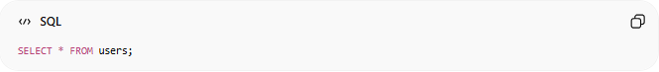
SELECT * FROM users;

3. PHP
# Source: AI Source: Provided by: [Data Path: Persons Table -> ID Column: 1, Name_En Column: Motasem Essam] -> From: [ChatGPT] on [6/1/2026]
🌟 Server-side programming language
Purpose:
- Process forms
- Build dynamic websites
- Create APIs
Example:
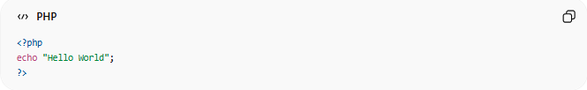
<?php
echo "Hello World";
?>

4. Perl
# Source: AI Source: Provided by: [Data Path: Persons Table -> ID Column: 1, Name_En Column: Motasem Essam] -> From: [ChatGPT] on [6/1/2026]
🌟 General-purpose scripting language
Purpose:
- Text processing
- Automation scripts
- Legacy web applications

5. phpMyAdmin
# Source: AI Source: Provided by: [Data Path: Persons Table -> ID Column: 1, Name_En Column: Motasem Essam] -> From: [ChatGPT] on [6/1/2026]
🌟 Database administration tool
Purpose:
- Create databases
- Manage tables
- Run SQL queries
Access:
http://localhost/phpmyadmin

🔗 How XAMPP Works
# Source: AI Source: Provided by: [Data Path: Persons Table -> ID Column: 1, Name_En Column: Motasem Essam] -> From: [ChatGPT] on [6/1/2026]
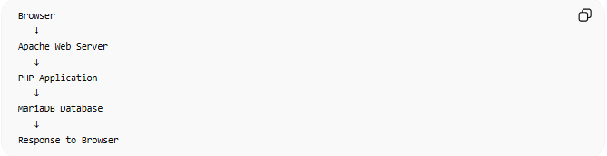
Browser
↓
Apache Web Server
↓
PHP Application
↓
MariaDB Database
↓
Response to Browser

📂 Typical Project Structure
# Source: AI Source: Provided by: [Data Path: Persons Table -> ID Column: 1, Name_En Column: Motasem Essam] -> From: [ChatGPT] on [6/1/2026]
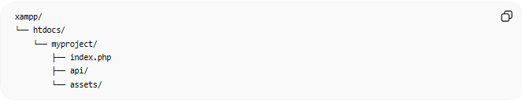
xampp/
└── htdocs/
└── myproject/
├── index.php
├── api/
└── assets/
Website URL:
http://localhost/myproject/

🛠 Common Uses
# Source: AI Source: Provided by: [Data Path: Persons Table -> ID Column: 1, Name_En Column: Motasem Essam] -> From: [ChatGPT] on [6/1/2026]
Website Development
- PHP websites
- WordPress sites
API Development
- REST APIs
- JSON APIs
Database Learning
- SQL practice
- Database design
Education
- Learning web development

⚖️ XAMPP vs WampServer
# Source: AI Source: Provided by: [Data Path: Persons Table -> ID Column: 1, Name_En Column: Motasem Essam] -> From: [ChatGPT] on [6/1/2026]
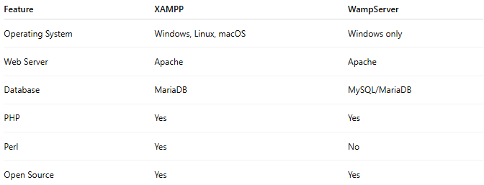
Feature | XAMPP | WampServer
Operating System | Windows, Linux, macOS | Windows only
Web Server | Apache | Apache
Database | MariaDB | MySQL/MariaDB
PHP | Yes | Yes
Perl | Yes | No
Open Source | Yes | Yes

🧠 Where XAMPP Belongs
# Source: AI Source: Provided by: [Data Path: Persons Table -> ID Column: 1, Name_En Column: Motasem Essam] -> From: [ChatGPT] on [6/1/2026]
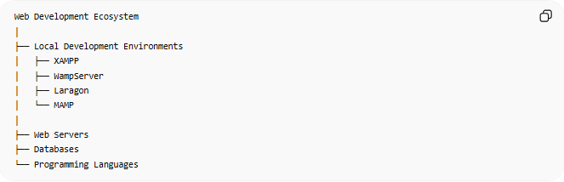
Web Development Ecosystem
│
├── Local Development Environments
│ ├── XAMPP
│ ├── WampServer
│ ├── Laragon
│ └── MAMP
│
├── Web Servers
├── Databases
└── Programming Languages

Download XAMPP
# Source: ScreenShot Source: Provided by: [Persons Table -> ID Column: 1, Name_En Column: Motasem Essam] -> Tool: [Automation Table -> ID Column: 16, Name_En Column: Screen Capture] -> From [Site: Google Search: All: XAMPP] on [6/1/2025]
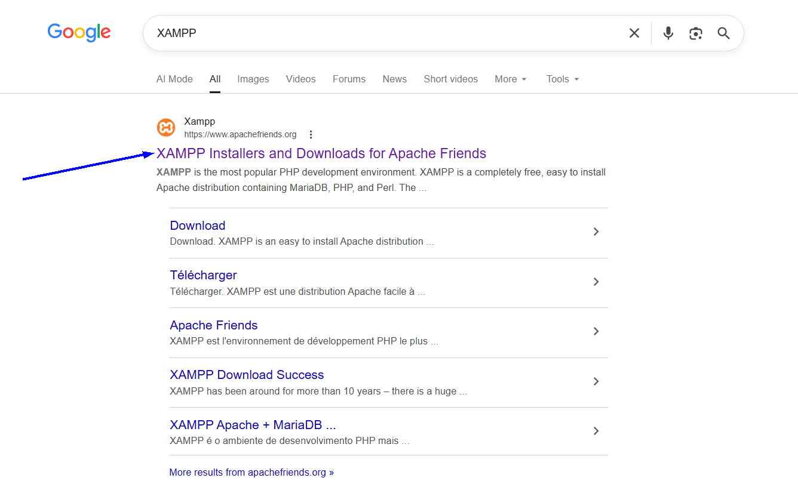
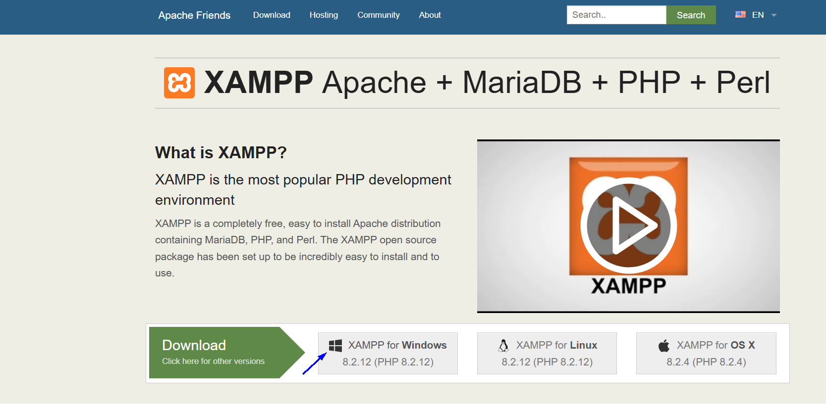

Install XAMPP
# Source: ScreenShot Source: Provided by: [Persons Table -> ID Column: 1, Name_En Column: Motasem Essam] -> Tool: [Automation Table -> ID Column: 16, Name_En Column: Screen Capture] -> From [Operating System: Windows] on [6/1/2026]
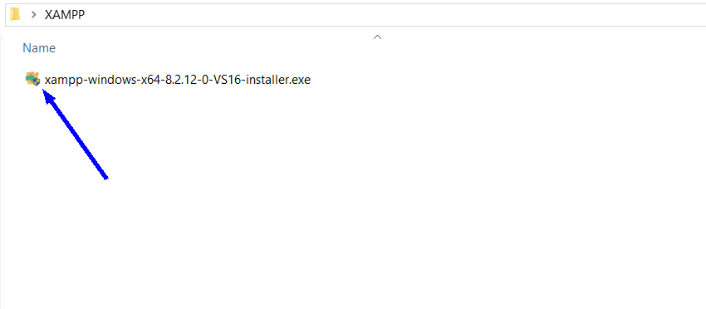
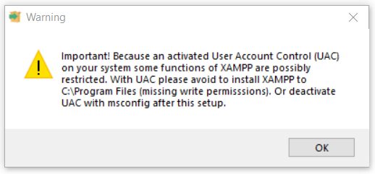
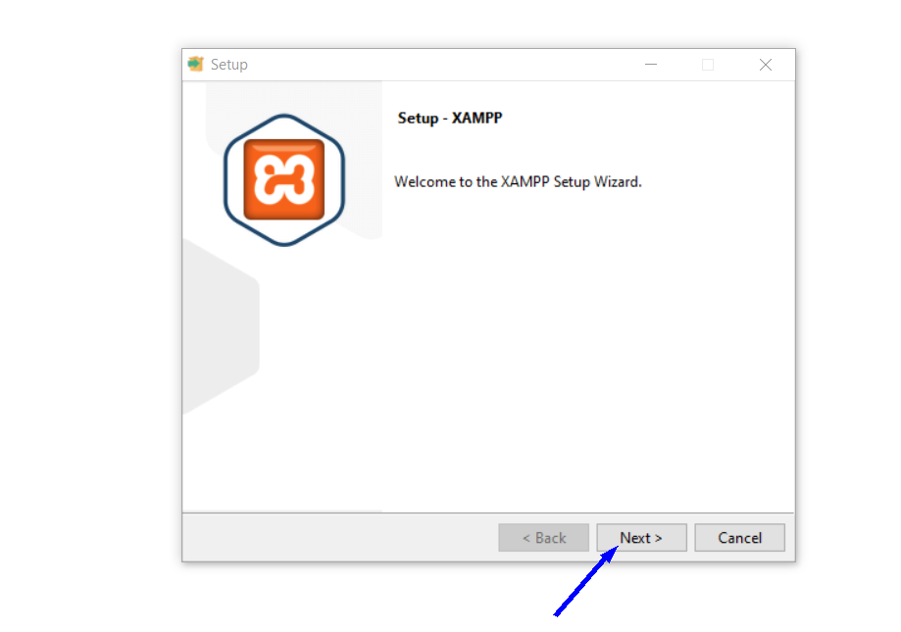
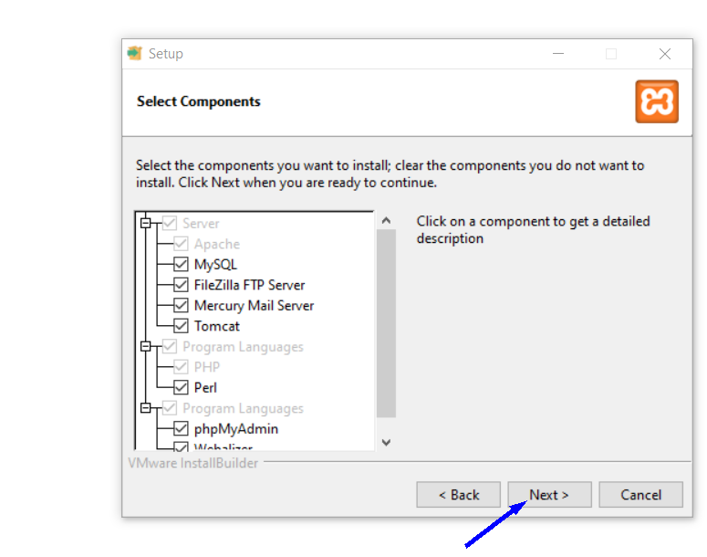
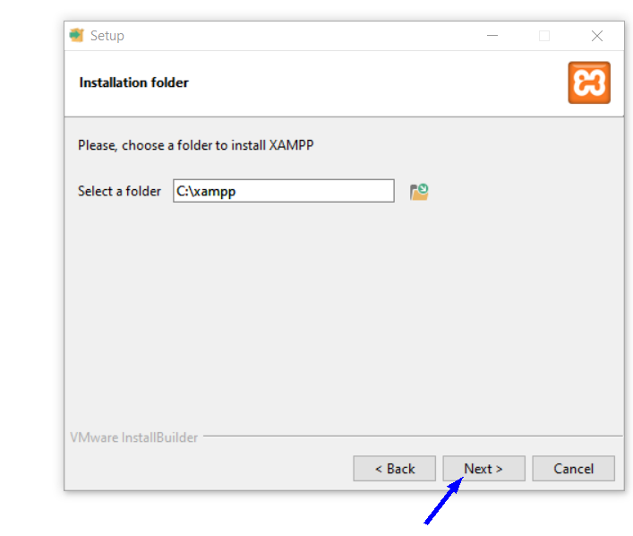
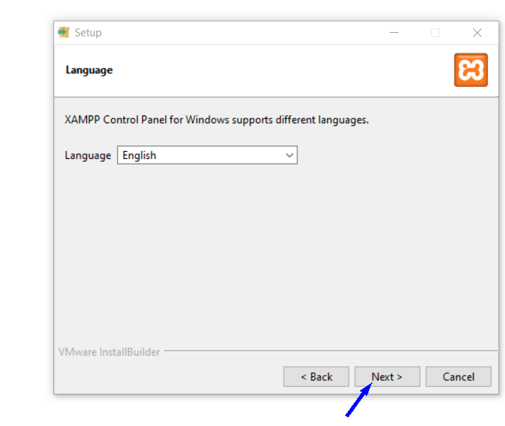
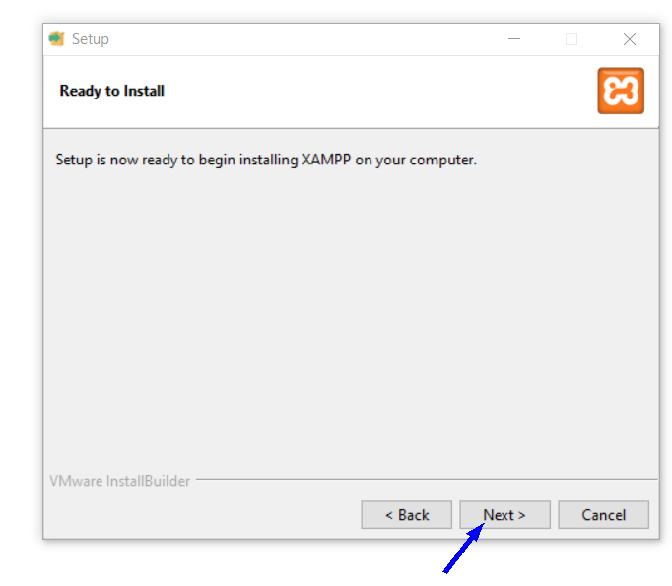
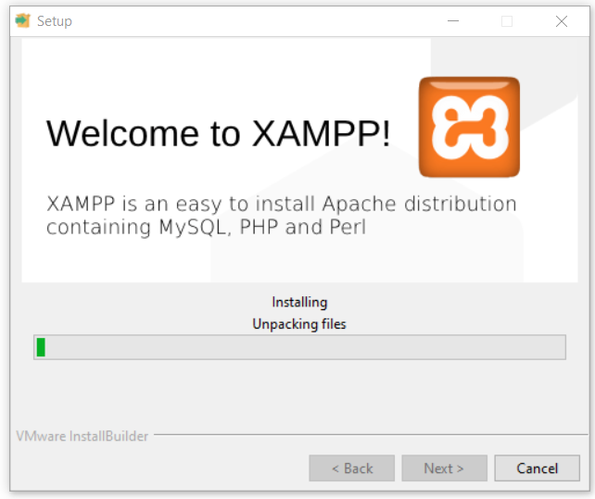

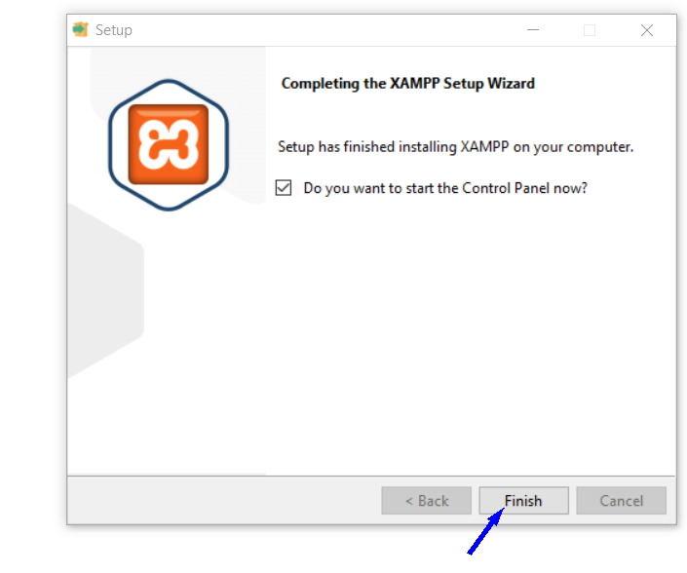

Run XAMPP
# Source: ScreenShot Source: Provided by: [Persons Table -> ID Column: 1, Name_En Column: Motasem Essam] -> Tool: [Automation Table -> ID Column: 16, Name_En Column: Screen Capture] -> From [Operating System: Windows] on [6/1/2026]
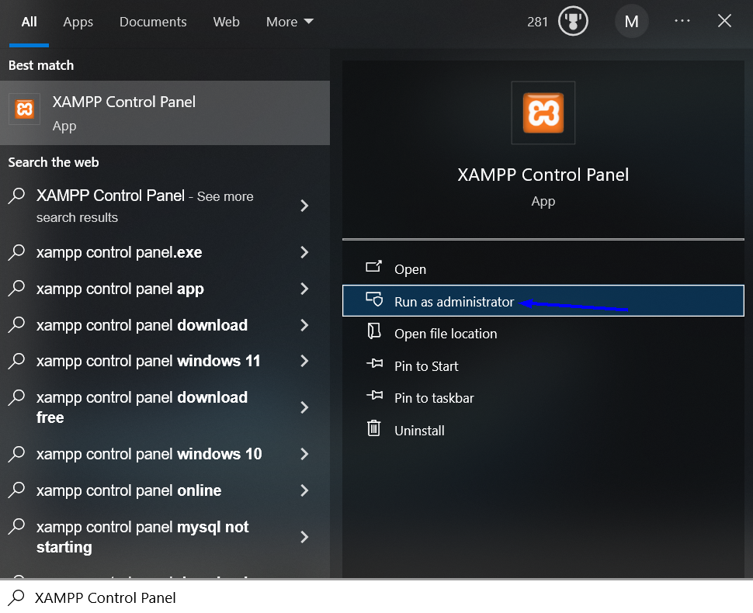
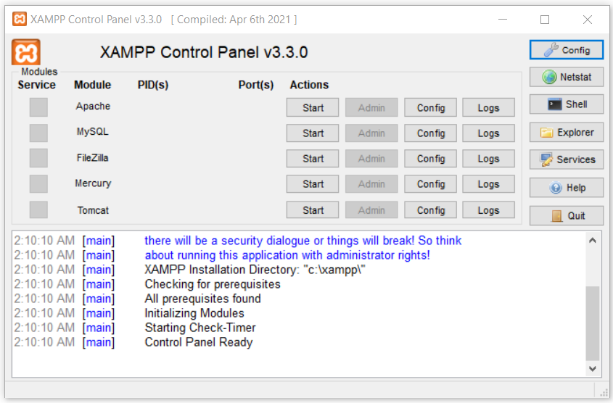

Start Apache
# Source: ScreenShot Source: Provided by: [Persons Table -> ID Column: 1, Name_En Column: Motasem Essam] -> Tool: [Automation Table -> ID Column: 16, Name_En Column: Screen Capture] -> From [Operating System: Windows] on [6/1/2026]
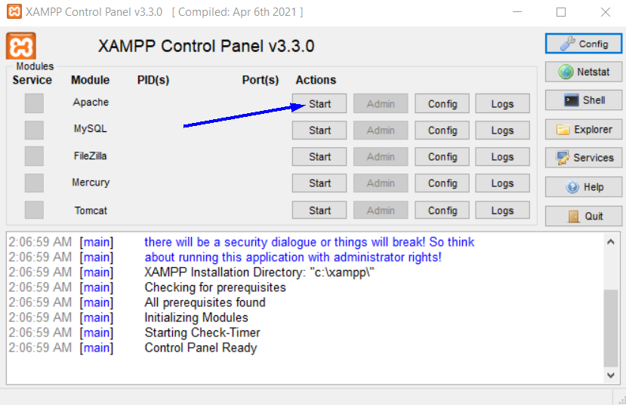
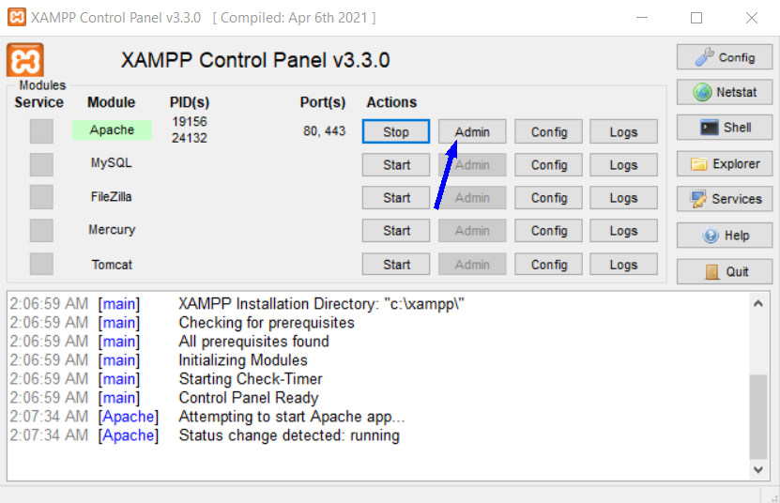

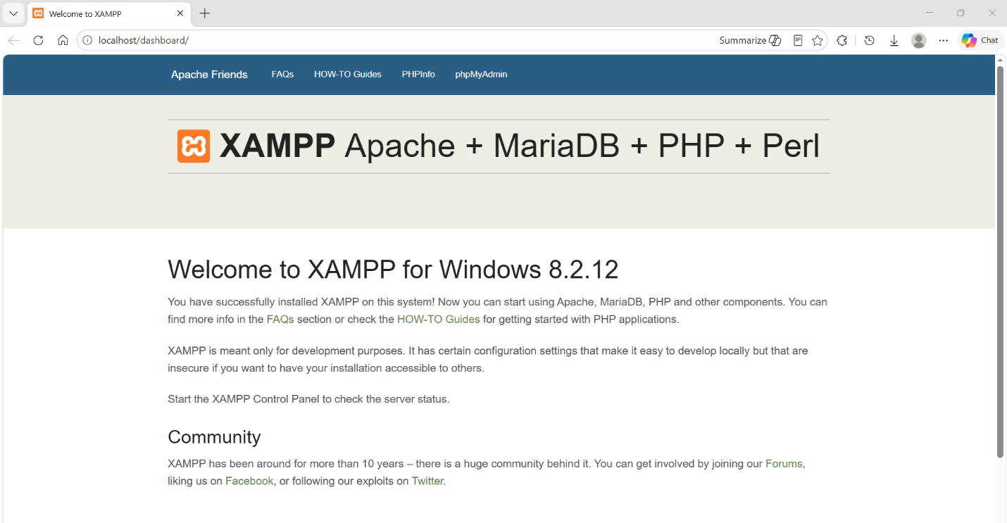
http://localhost/dashboard/

Start MySQL
# Source: ScreenShot Source: Provided by: [Persons Table -> ID Column: 1, Name_En Column: Motasem Essam] -> Tool: [Automation Table -> ID Column: 16, Name_En Column: Screen Capture] -> From [Operating System: Windows] on [6/1/2026]
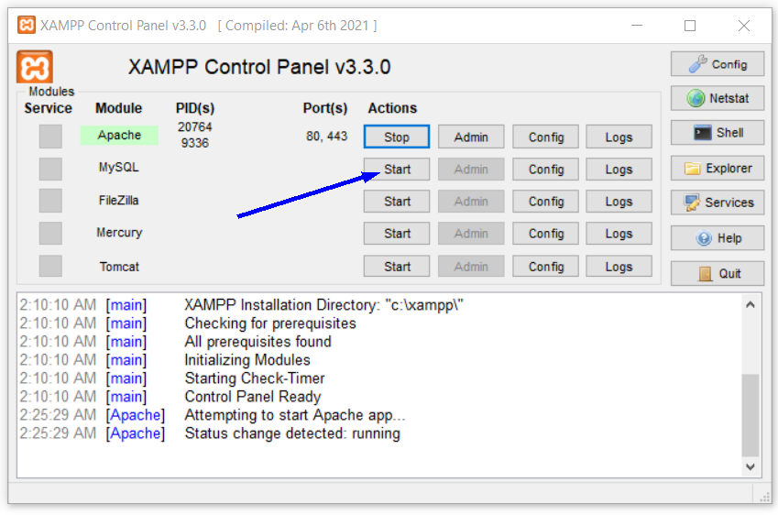
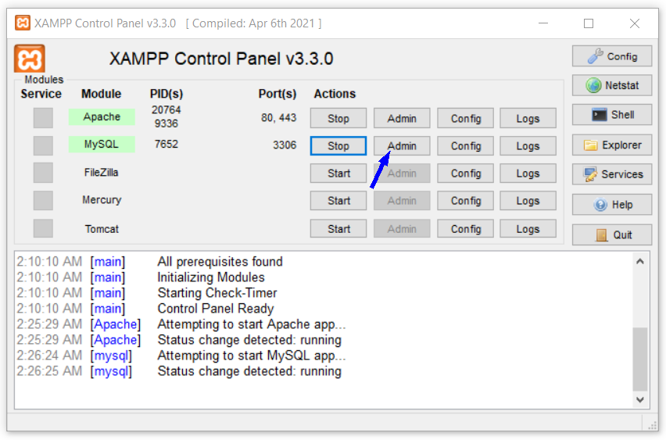
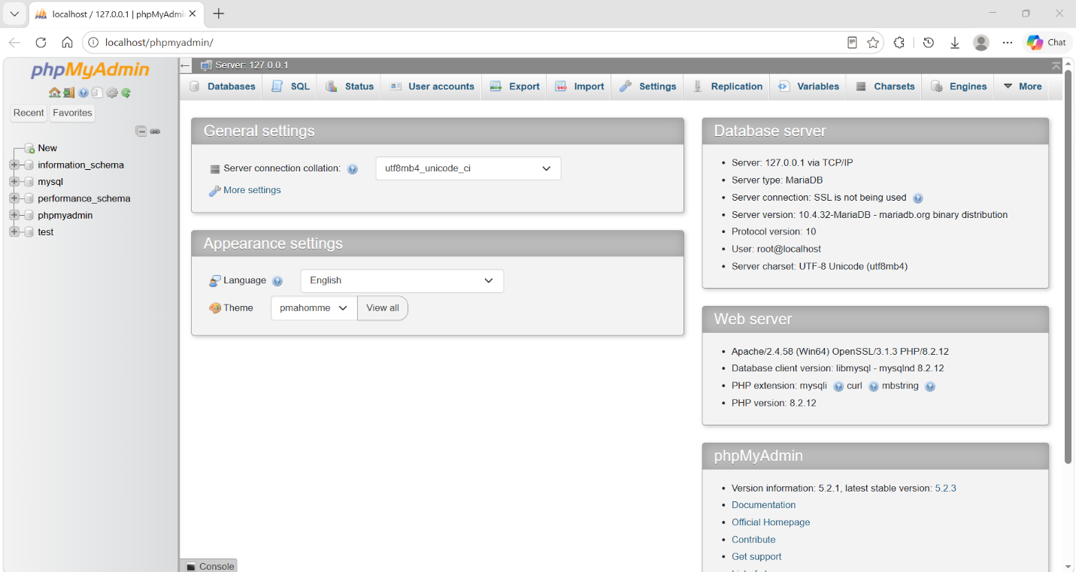
http://localhost/phpmyadmin/

Create a Project Folder
# Source: ScreenShot Source: Provided by: [Persons Table -> ID Column: 1, Name_En Column: Motasem Essam] -> Tool: [Automation Table -> ID Column: 16, Name_En Column: Screen Capture] -> From [Operating System: Windows] on [6/1/2026]
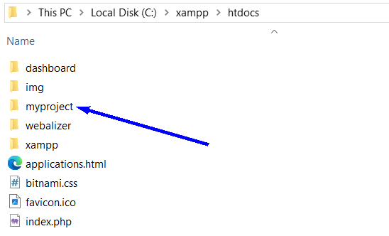

Create index.php
# Source: ScreenShot Source: Provided by: [Persons Table -> ID Column: 1, Name_En Column: Motasem Essam] -> Tool: [Automation Table -> ID Column: 16, Name_En Column: Screen Capture] -> From [Operating System: Windows] on [6/1/2026]
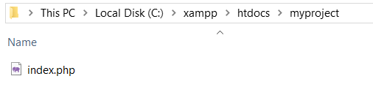
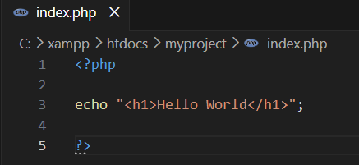
<?php

echo "<h1>Hello World</h1>";

?>

Open index.php
# Source: ScreenShot Source: Provided by: [Persons Table -> ID Column: 1, Name_En Column: Motasem Essam] -> Tool: [Automation Table -> ID Column: 16, Name_En Column: Screen Capture] -> From [Operating System: Windows] on [6/1/2026]
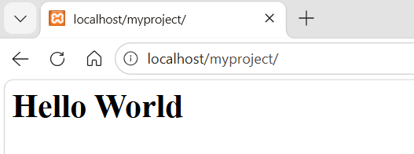
localhost/myproject/

🧭 Summary
# Source: AI Source: Provided by: [Data Path: Persons Table -> ID Column: 1, Name_En Column: Motasem Essam] -> From: [ChatGPT] on [6/1/2026]
XAMPP is a cross-platform local web server package that combines Apache, MariaDB, PHP, and Perl into one environment, allowing developers to build, test, and run websites and APIs on their own computers before deploying them to a live server.

